**IBM ASSIGNMENT 01**

|  |  |
| --- | --- |
| Assignment date | 19 september 2022 |
| Student name | Hariharan D |
| Student roll number | 73771913126 |
| Maximum marks | 2 marks |

Question-1:

smart home automation designs provide an unprecedented level of comfort and convenience in Melbourne homes, delivering you a personalised and innovative room experience.

**Solution:**

#include <Servo.h>

Servo myservo;

int led=6;

int pir=2;

void setup()

{

Serial.begin(9600);

pinMode(pir,INPUT);

pinMode(led,OUTPUT);

myservo.attach(9);

}

void loop()

{

int val=digitalRead(pir);

Serial.println(val);

if(val==HIGH)

{

digitalWrite(led,HIGH);

myservo.write(70);

}

else

{

digitalWrite(led,LOW);

myservo.write(10);

}

}

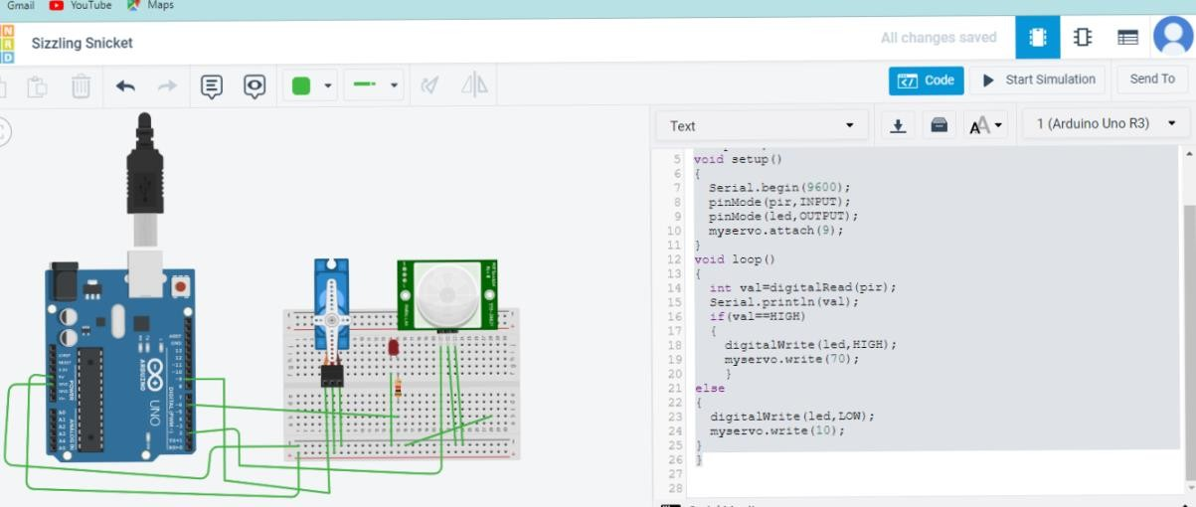**OUTPUT :**

